Ryan Dahl



<https://www.youtube.com/watch?v=w-7RQ46RgxU&list=PL4cUxeGkcC9gcy9lrvMJ75z9maRw4byYp>

The Net Ninja

Node.js is a javascript runtime built on Chrome’s V8 JavaScript engine. Node.js uses an event-driven, non-blocking model that makes it lightweight and efficient. Node.js package ecosystem, npm is the largest ecosystem of open source libraries in the world.

# Node.js Actually is …

* A platform which allows us to run JavaScript on a computer/server.
* Read, Delete and update files.
* Easily communicate with a database.

Why is Node.js so popular …

* It uses JavaScript
* Very fast (runs on the V8 engine & uses non-blocking code)
* Huge ecosystem of open source package (npm)
* Great for real time services (Like chats)

What we’ll learn …

* The inner workings of Node.js
  + V8 engine
  + Modules
  + Event Emitter
  + The file system
* Creating a Web Server
  + Routing
  + Express
  + Templating
* Make a node.js application (todo app)

What you need to know …

* JavaScript
* HTML
* A tiny bit about the command line

Install Nod.js …

<https://nodejs.org/en/>

Hello World Example …

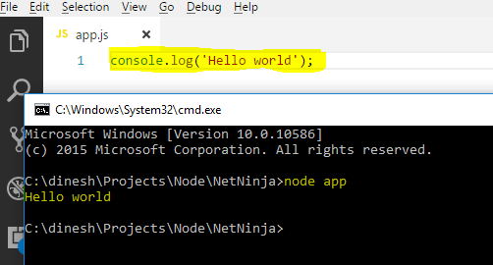

Global Object (like windows in browser) …

Module Patterns …

# The Event Module …

* events.spec.js

# Reading and Writing Files …

* read-and-write-file-sync.spec.js
* read-and-write-file-async.spec.js

# Creating Removing Directories …

* creating-removing-directories-sync.spec.js
* creating-removing-directories-async.spec.js

# Client and Server …